**CMPE275 TEAM PROJECT PLAN**

**Group 7**



|  |  |  |
| --- | --- | --- |
| **Member Name** | **Email ID** | **SJSU ID** |
| Anuja Asalkar | anuja.asalkar@sjsu.edu | 010734841 |
| Sachin Mallikarjun Hunur | sachinmallikarjun.hunur@sjsu.edu | 010374559 |
| Shikha Kukreja | shikha.kukreja@sjsu.edu | 010709426 |
| Sindhuja Narra | Sindhuja.narra@sjsu.edu | 010742667 |

Submitted to: Professor Charles Zhang

**Technologies**

Web Technologies - HTML, CSS, Bootstrap, AJAX, JSP

Framework – AOP Framework, Hibernate (Data Access Framework), Spring MVC web application framework, Transaction Management Framework

Databases - MySQL/MongoDB

Cloud computing services - Amazon Web Services

Server – Apache Tomcat Server

**Architecture**

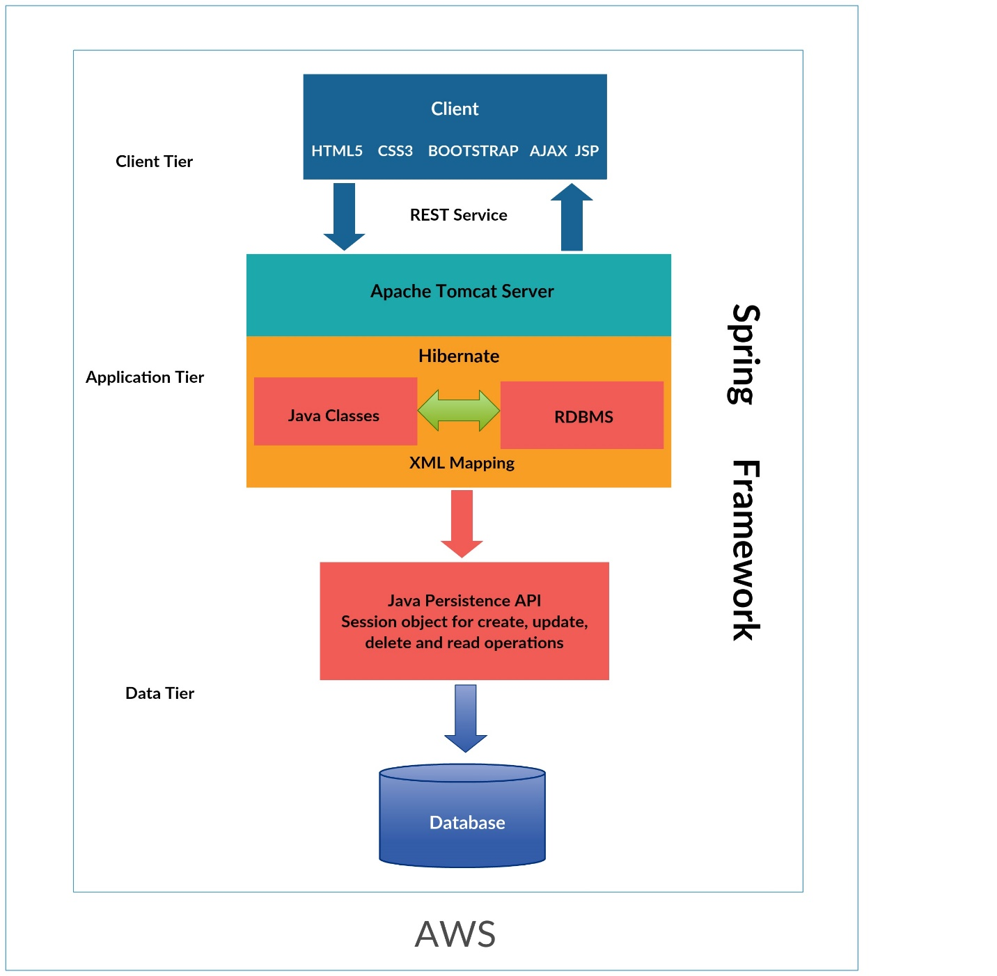

**Distribution of Work**

Anuja:

* Customer Sign up and Sign in module (includes authentication)
* Validating order time (30 days,6am – 9pm)

Sachin:

* Add/ remove and reset menu item (admin job) with end-to-end functionality
* Checking availability of cook (free cook)

Shikha:

* Schema designing, creation of tables in database and POJOs
* Designing algorithm for assigning cook for order (implementing the validations)

Sindhuja:

* Deployment on AWS (includes taking care of all set ups viz., MySQL etc).
* Test case development and Bill generation

**Milestones with expected dates**

|  |  |
| --- | --- |
| **Feature** | **Expected Date** |
| Schema Designing and POJO Creation | 04/24/2016 |
| Customer Sign up and Sign in | 04/26/2016 |
| Add, Remove and Reset Menu Items | 04/29/2016 |
| Order Placement (validating order time) | 05/02/2016 |
| Check Availability of Cook | 05/04/2016 |
| Design Algorithm for Assigning Order to a Cook | 05/08/2016 |
| Bill Generation and Deployment | 05/09/2016 |
| Testing | 05/10/2016 |